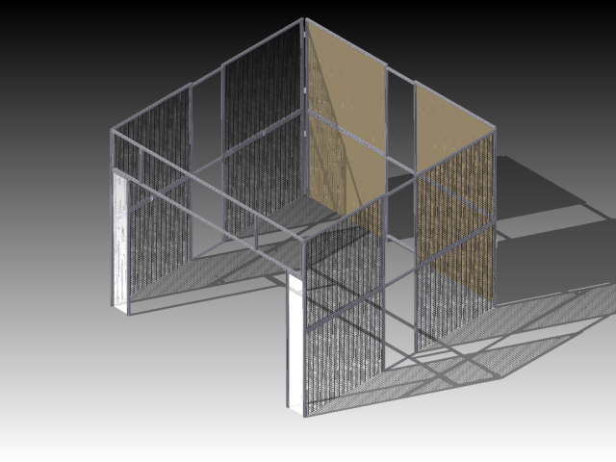

Bill Of Materials
Quantity | Part Name- Things That Go on the Pit
2 | Back bottom corner panels
2 | Back top corner panels
2 | Bottom side panels
2 | Top side panels
3 | Short tie bars
6 | Long tie bars
18 | Tie bar hardware (Circular connector, long screw, t-nut)
1 | Front panel
1 | Marquee
2 | Picture panels
4 | Picture panel save bars
4 | Long cap head screws
4 | Large washers
6 | Top and bottom panel connector bracket
12 | Connector pegs
6 | Top to bottom panel connector brackets
6 | Button head screws
16 | Flat head screws
22 | T-nuts
24 | Foam floor tiles (5X5 space, one tile skipped)(outside tile edges trimmed)
8 | Yellow foam tile wedges
4 | Wire wall shelves
5 | Wall hanging hooks
1 | Wire paper holding rack
1 | Eye wash station
1 | Fire extinguisher and hanging hardware
1 | Fire extinguisher sign
1 | Container of ear plugs
1 | Yellow safety chain
1 | Large dry erase board
Assorted | Posters
Many | Assorted zip ties
Several | 4 mm ball end Allen wrenches
Several | 5 mm Allen wrenches

Quantity | Name- Things That Go In the Pit
1 | Big red toolbox
1 | Mechanical cart
1 | Programming cart
1 | Blue hardware bin
1 | Item box
1 | Battery cart with batteries and chargers
1 | Batter spill kit
1 | Battery check in/out clipboard
1 | Battery beak meter
1 | Driver’s station
1 | Driver’s station lap top and cord
2 | Pit bins (one red, one black)
1-2 | Safety bins
1 | Judges bin
1 | Scouting bin
1 | Button container
Assorted | Extra bins of supplies
1 | Small shop vacuum
1 | Electrical/controls tackle box
1 | Long power strip
Several | Extension cords
Several | Regular power strips
1 | Trash can
1 | Broom and dustpan
1-5 | Pit clip boards
Various | Colored dry erase markers
1 | Dry eraser
1 | Bottle of safety glass cleaner
1 | Box of towelettes
1 | Bottle of hand sanitizer
1 | First aid kit
1 | Body fluid disposal kit
1 | Decimeter
1 | Safety training manual
1 | MSDS binder
1 | Inspection binder
4 | Hardhats
23 | Picture frames
1 | Lock-out-tag-out box and clip
Several | Spare safety glasses

NOTE: All directions are from the perspective looking at the front of the pit.

- Gather all needed pieces and parts. Put everything in the center of the 10’ X 10’ space.

- Begin with the bottom, back corners, unfolding and setting them up all the way into the back corners of the 10x10 pit space. (Peg boards go to the back with plastic screens on the sides.)

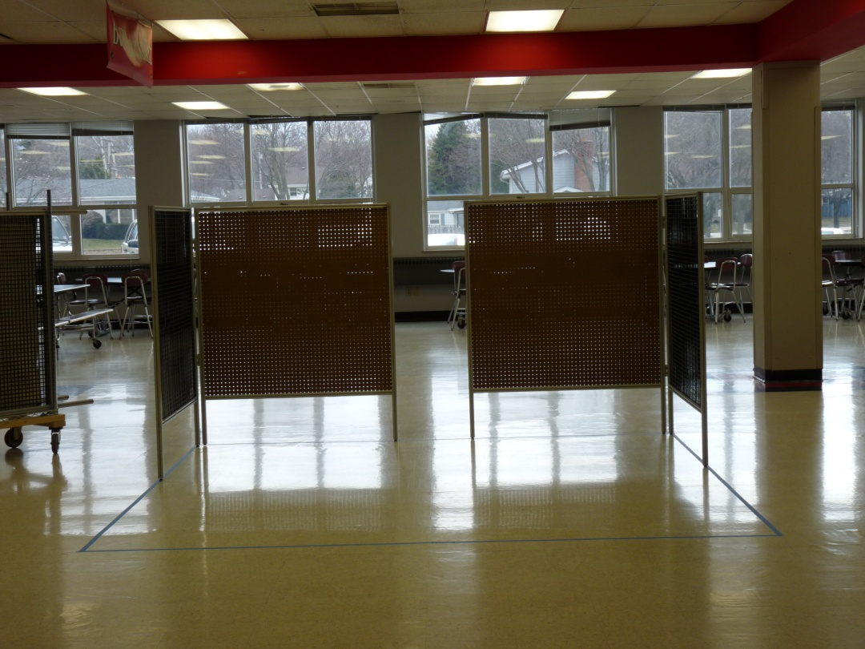

- Once they are in place, add the back tie bars, one in line with the bottom horizontal pit frame piece and one in line with the top horizontal pit frame piece. Tie bars for the back are marked with an S because they are shorter. To attach them, use a 4mm ball end Allen wrench to tighten the circular insets with the screw through it and the t-nut on the end. Ensure the flat part of the circular insert is facing out.

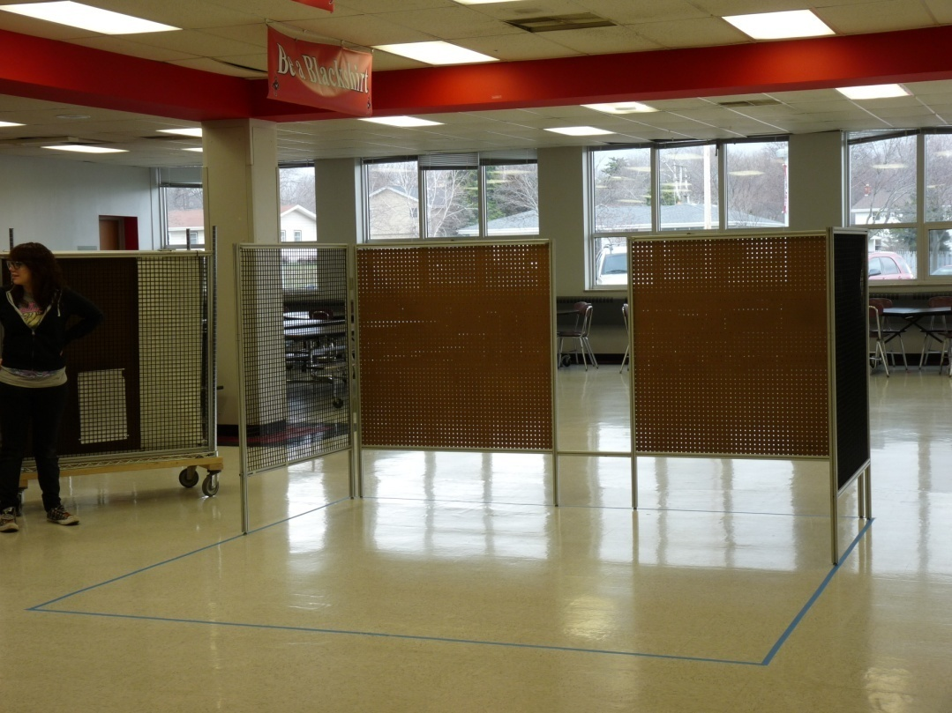
Back tie bar.
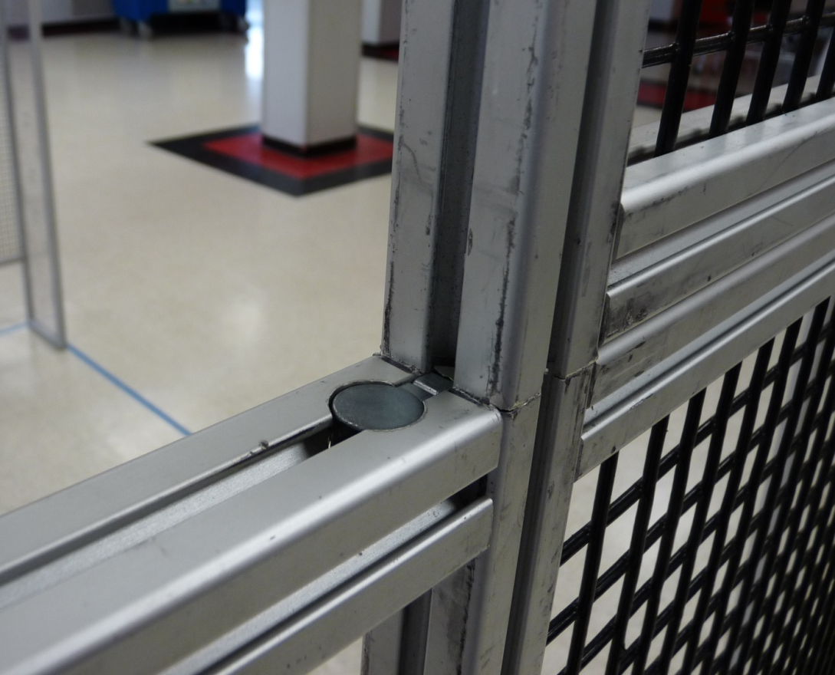
Tie bar connector hardware. Circular part facing out.
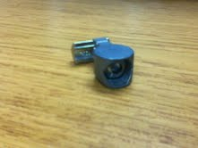

- Place the bottom front panels in line with the back corner panels, ensuring that the panels are on their correct sides. Make sure that people are supporting the loose frame until it is completely put together.
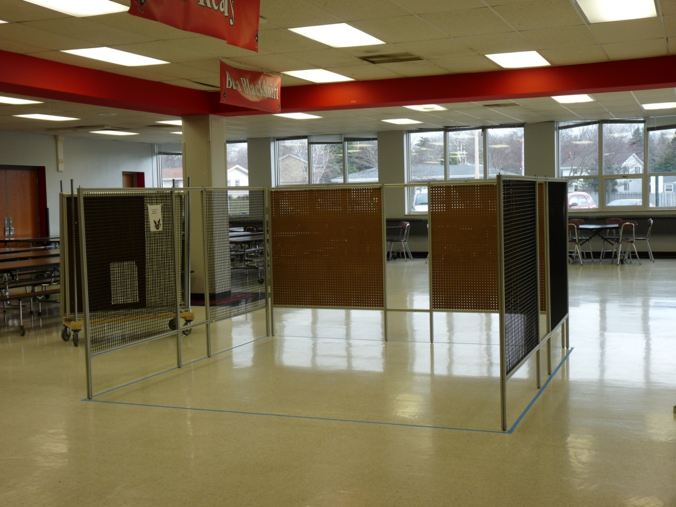
Tie bars (2 per side)
Tie bars.
Side panels.

- Add two tie bars to each side, lining them up the same as they were in the back (one on bottom and one on top.) Note that the tie bars on the sides are longer than the ones in the back.

- Next, put pegs for top sections in the holes of all the upright item frame pieces. There should be 12 pegs total put into the frame. Make sure the pegs are halfway inserted, as shown.

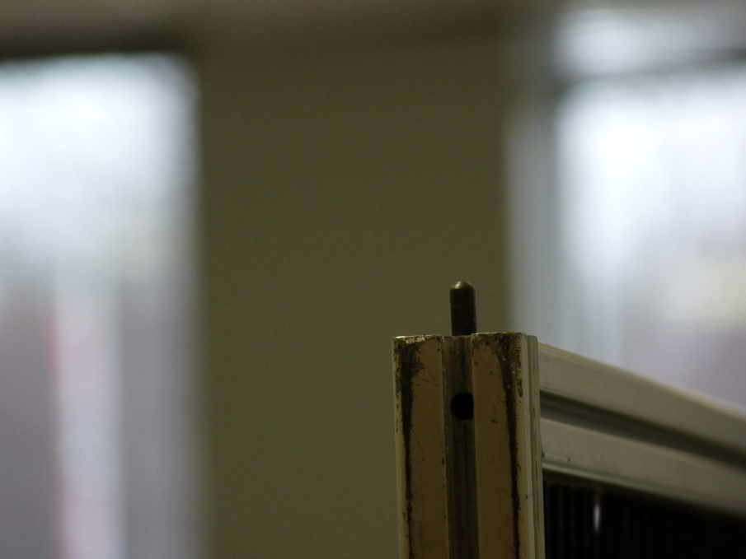
Pegs.
- Put the top back corners up, making sure the peg board is in the back. The pegs in the bottom frame pieces should line up with the top pieces. Add the tie bar in line with the top of the item frame. Make sure there are people supporting the top of the frame as it is being secured in place.

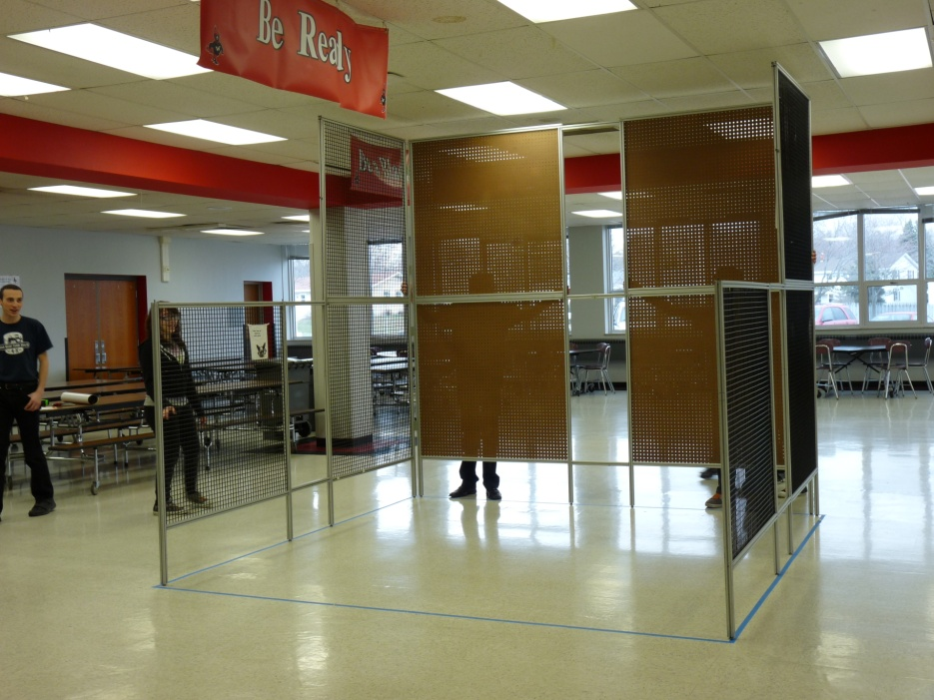
Top back corners.
Top tie bar.

- Add the top side panels with their tie bars, making them even with the top of the frame. Ensure that the sides are correct. Make sure all the pegs from the bottom are lined up and that long tie bars are used to secure the panels. Make sure there are people supporting the sides while they are being put together.

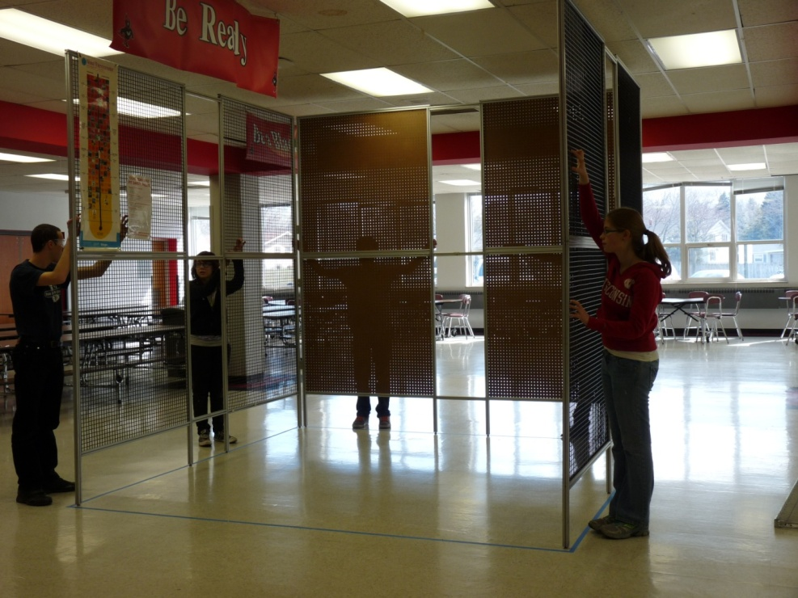
Top tie bars.
Top side panels.
- Next, add the front panel that goes all the way across the front of the pit. Put four t-nuts, two in each side, into the front of the vertical item bars of the bottom side panels. Put short, flat headed screws through the brackets on the front panel and begin to tighten them with a 4 mm Allen wrench into the t-nuts but don’t tighten them completely. This will keep the front panel in place while adding the marquee.

- Put the marquee on the front panel using four t-nuts, two on each side, into the inside of the inner supports of the front panel and use four button headed screws in the top back and bottom forward screw holes of the marquee support brackets. Make sure the marquee is pushed all the way to the top of the inside of the front panel and tightened completely with a 4 mm Allen wrench.

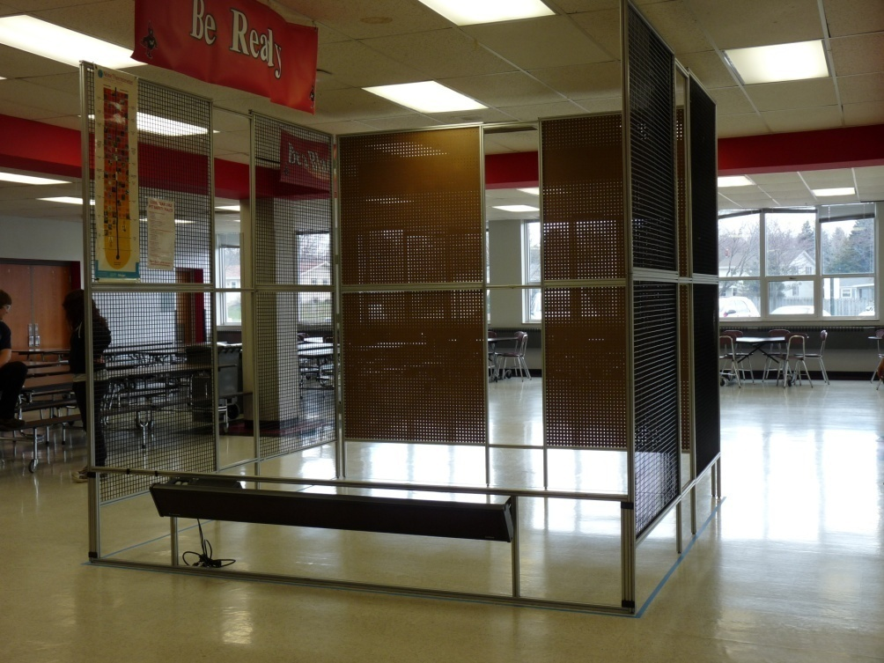
Inner supports of front panel.
Front panel brackets.
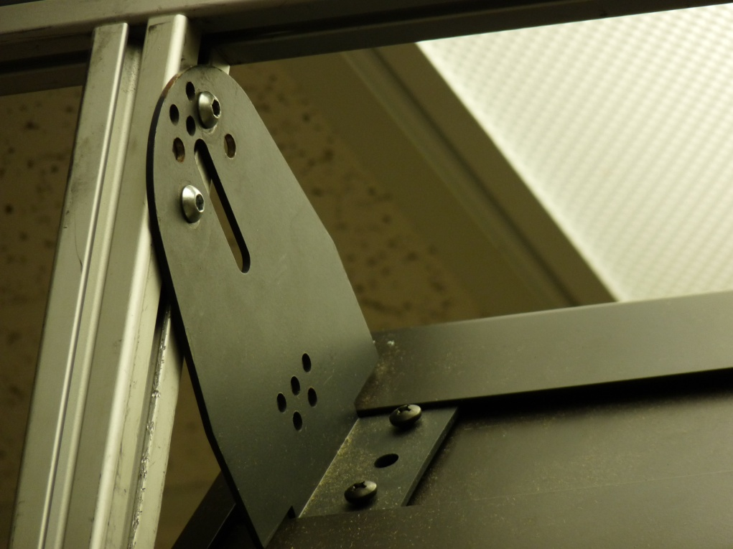
Marquee support bracket.
Marquee screws.

- Next, carefully and slowly, slide the front panel, with the marquee, to the top of the pit frame, keeping it level and making it even with the top of the side panels. Make sure the sides are supported as the front panel goes up and that it is going up level and horizontally to keep it from getting wedged. Use a ladder to get it all the way to the top.

- Have the picture panels ready to go under the front panel and support it once it is all the way to the top of the frame. (Make sure the small save bars on the top and bottom of both picture panels are off the picture panels and that the bar, screw and washer are put back in the pit hardware box.) Slide the picture panels under the front panel on each side, making sure the feet are at the bottom and the Velcro strips on the poly carb are facing out. Once the front panel is flush with the top of the side panels and the picture panels are in place, have someone on a ladder, carefully and being spotted, use a 4 mm Allen wrench tighten the flat-head screws into the t-nuts of the front panel brackets.

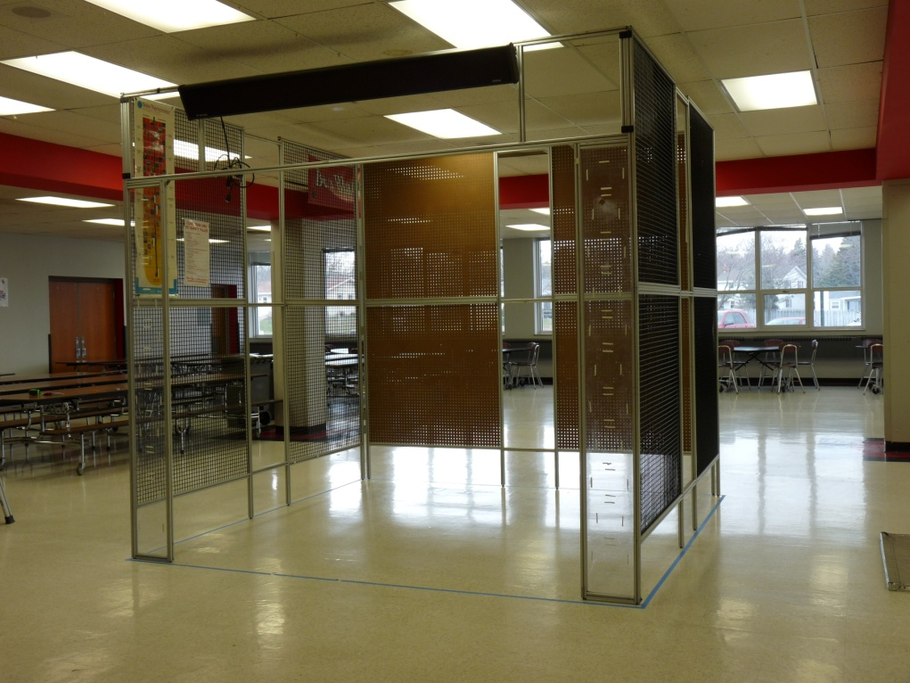
Picture panels.
Front panel to top.

- To secure the picture panels, take two t-nuts, one for each side, and put them in the bottom of the bottom support of the front panel close to the triangular support of the picture panel. Use a 4mm Allen wrench to slide it into place with the hole of the t-nut lines up with the hole of the support. Take two button head screws, one for each side, and tighten them into the t-nuts through the triangular brackets.

Triangular bracket.

- Next, take one of the screws and washers saved from the picture panel save bars and use a 5 mm Allen wrench to screw it into the outside of the side panel and into the bottom horizontal item bar on the picture panel. This may require the picture panel to be lifted up slightly so the screw will be lined up.

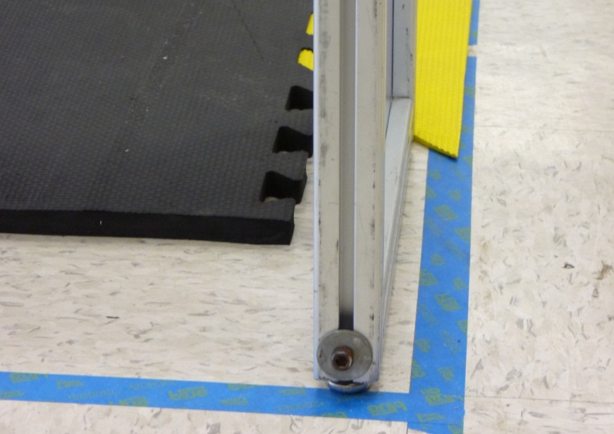
Washer and screw from save bar.

- Now start adding in the floor tiles. Start in the back left corner and work sideways, then forward. The tiles should be numbered and labeled. The tiles on the sides and back should have smooth edges, with no connecting bumps. In the second row from the back on the far right side, leave a tile out for the battery cart. Once they are all in, add the yellow tile wedges to the front of the tiles at the front of the pit.

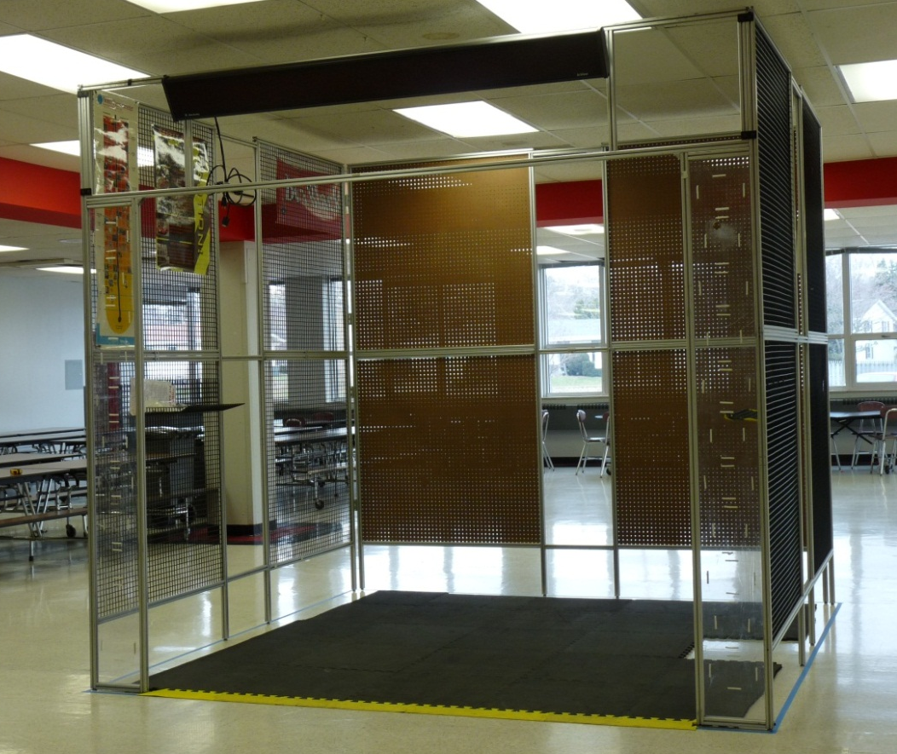
Yellow tile wedges.
Skipped tile.
Start here.

*Now it’s time to start organizing the bins, tool boxes and carts in the pit*
- Start with moving the big red toolbox to the center of the back, making it as flat against the back wall as possible. Also, having the wheels tucked under the cart will be helpful for working later. Place the small shop vacuum, zip ties and electrical/controls tackle box on top.

- Run the long power strip behind the toolbox and make sure it is plugged in.

- Next, the mechanical cart on the left and the programing cart on the right. On top of the mechanical cart, put the blue hardware bin and the item box on top of that. Small Quick clamps can go on the side of the cart. On top of the programming cart, put the driver station and laptop and make sure the laptop charger is plugged in and the cord comes to the top of the cart so it is accessible. The laptop cases can go between the red tool box and the programming cart.

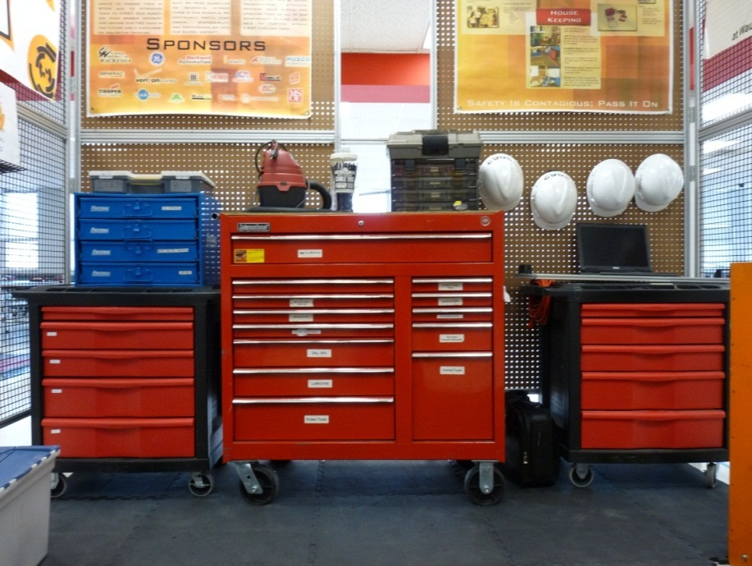
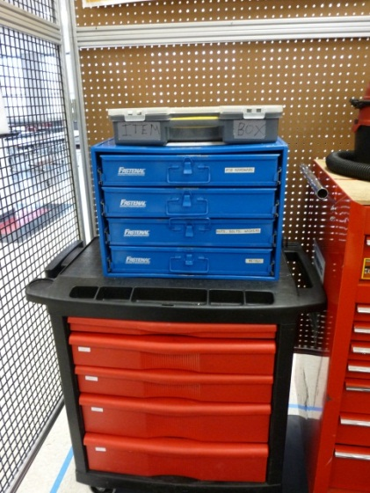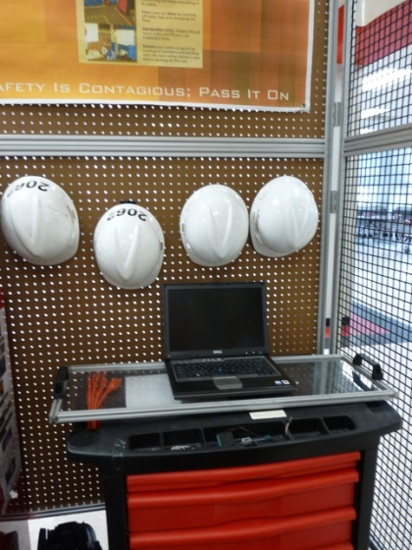
(Now that these are in, the rest of the steps can be done at the same time and out of order, their sequence is unimportant.)

- Add small brackets with two t-nuts and two flat head screws to connect the top and bottom of each section of panels. One bracket goes between the top and bottom of each other the front, top and bottom panels and the back corner top and bottom panels on the side and back.

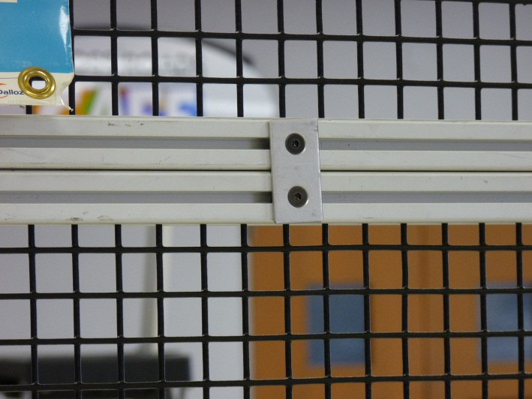

- Place the battery cart where the tile was left out for it in the second row of tiles on the far right side. Make sure that the batteries are facing the front of the pit, with the chargers facing the back. Plug in all chargers and batteries, but make sure to unplug them at the end of each day. Put the battery spill kit with the battery beak inside, on top of the battery cart, with the battery check in/check out clipboard on the top as well.

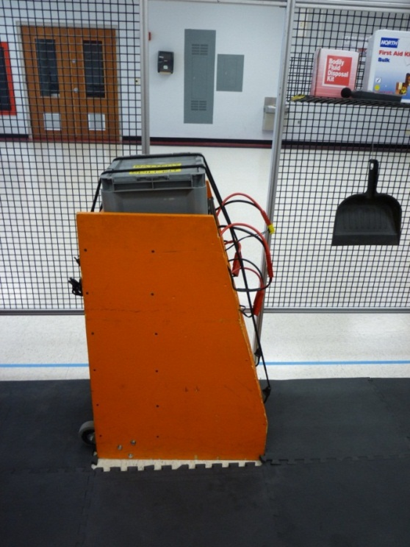

- Arrange the bins of pit set up parts, safety, judges, giveaways and any others needed along the left wall of the pit. Leave one empty bin on the bottom of one of the stacks for pit crew’s personal belongings. In the stack closest to the front of the pit, put the giveaways and judging bins with the button container on top so Chairman’s spokespeople can access them easily. Have the safety bin in the next stack over on the top also.

- Put the trash can, broom and dustpan in the front right corner of the pit. The dustpan hangs on the wall with a hook. Also add the eyewash station with no-drop zone (Put yellow caution tape in a rectangle with an x through it to indicate that nothing can be placed there), fire extinguisher, ear plugs and a shelf for the first aid kit, body fluid disposal kit and decimeter to the right wall.

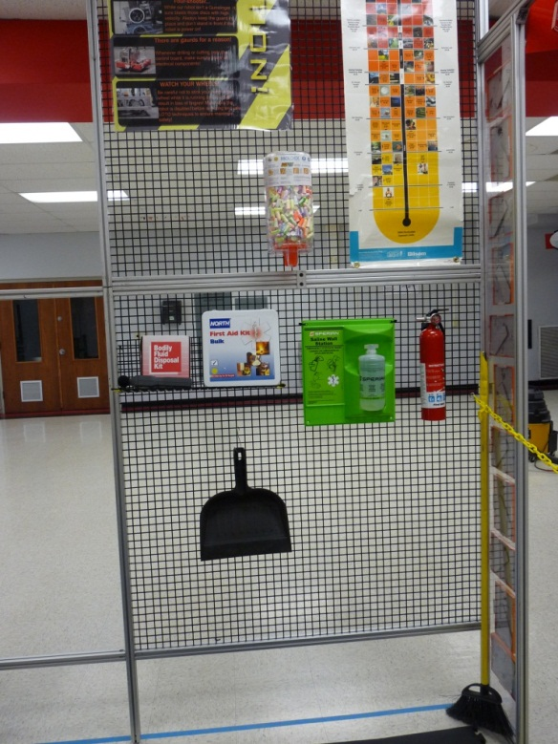

- Add the shelves and paper rack to the walls, along with the dry erase board on the front left wall. The placement of the shelves for pit clipboards and dry erase markers doesn’t have to be exact, but the rack for safety manuals and judges packets should be as far to the front as possible. One shelf should be on the back left wall for the inspection binder, Safety Training Manual and MSDS sheets binder. There should be two shelves on the front left side panel. The pit clipboards and dry erase markers go on one shelf, and the hand sanitizer, safety glasses cleaner, towelettes and the lock-out-tag-out box on the other. Extra safety glasses and lock-out tags can be hung on this wall as well in the open spaces.

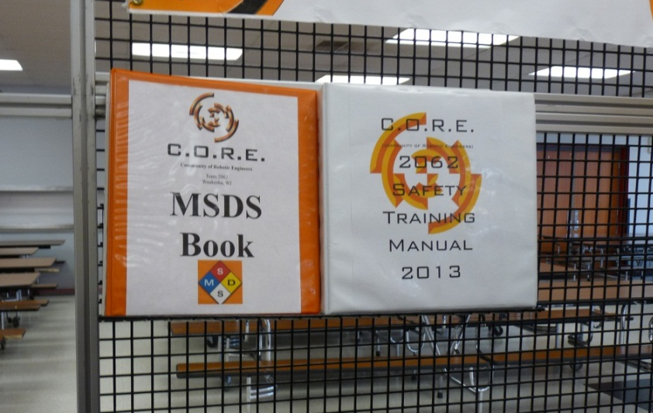
Wire shelf.

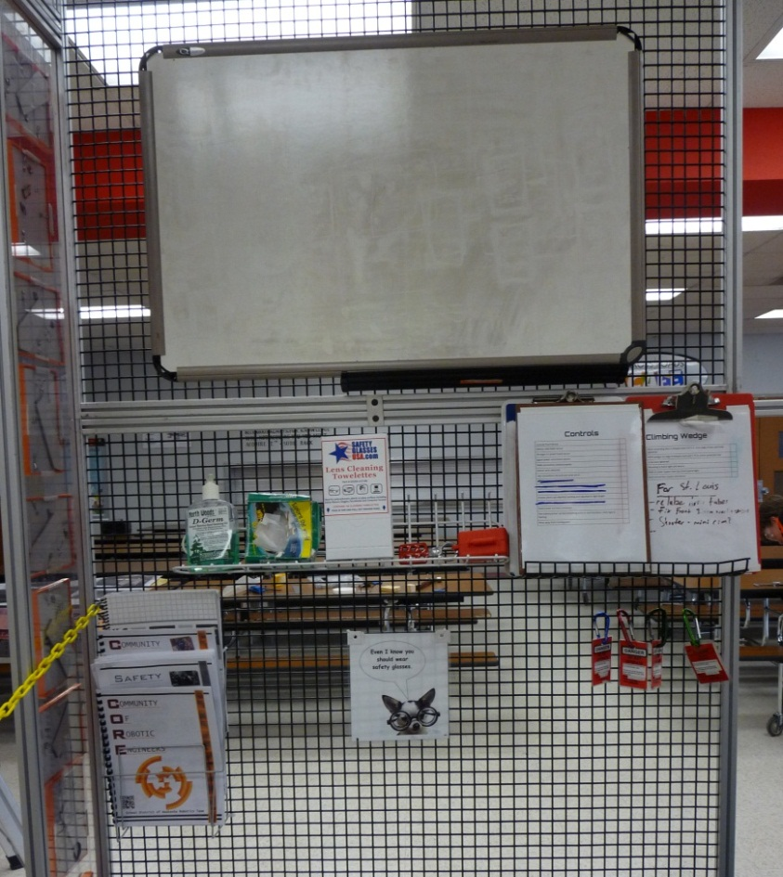
Wire shelves.
Wire paper rack.
- Add four hooks for the hard hats on the back beg board above the programming cart. Stagger the hooks so that the hats hang better.

- Add the yellow safety chain across the front of the pit.
Picture frames.
Yellow safety chain.

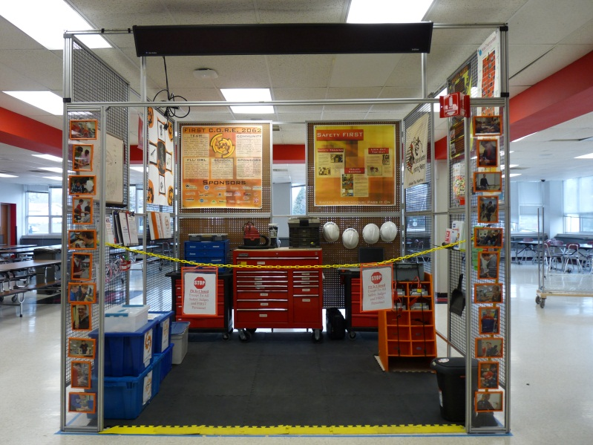

- Add the picture frames to the front of the picture panels.
- Using zip ties, hang the American flag from the top tie bar on the right side between the front and back side panels.
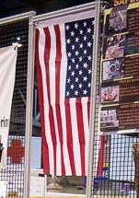

- Check all the posters and make sure they are up to date.

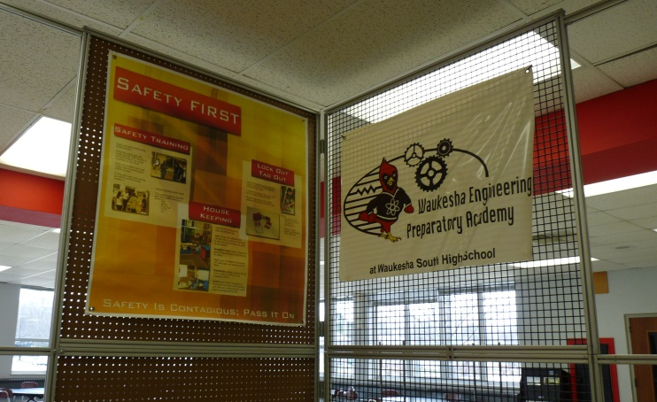
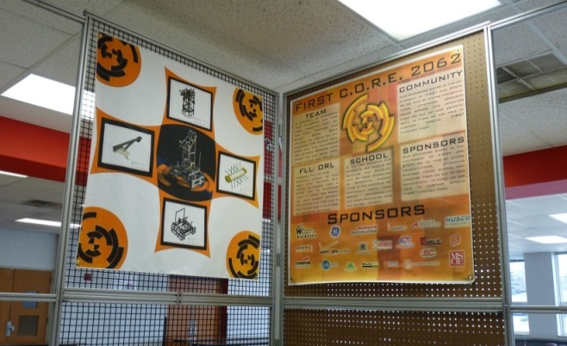

- Keep the pit clean and orderly while working. This will keep the pit a safe area and allow work to get done quickly and efficiently.

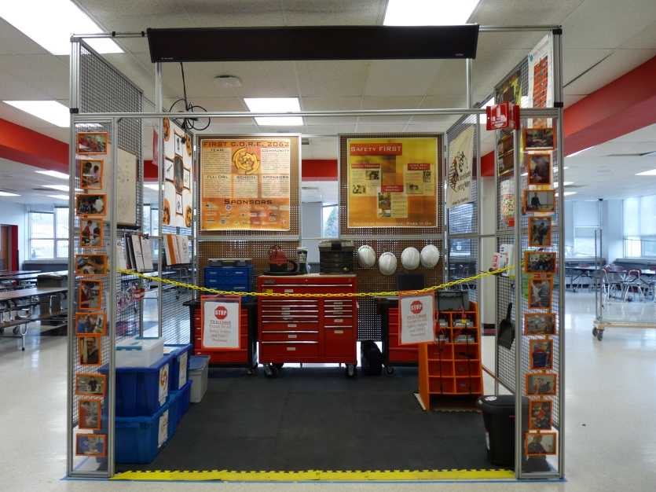
Good Luck Team!

(Last Revision: January 6, 2014. Annalyssa Martin)

Remember:

Your instructions are only helpful if they are detailed and up to date!

As changes are made, edit the instructions so they match the new set-up process.

The file can be found: On Mr. Spoerk’s H: Drive, in My Documents, Robotics 13, Pit Set-up Manual.

